**Prometheus Installation:**

Username Creation:

sudo useradd \

--system \

--no-create-home \

--shell /bin/false Prometheus

Command:

wget https://github.com/prometheus/prometheus/releases/download/v2.47.1/prometheus-2.47.1.linux-amd64.tar.gz

tar -xvf prometheus-2.47.1.linux-amd64.tar.gz

sudo mkdir -p /data /etc/prometheus

cd prometheus-2.47.1.linux-amd64/

sudo mv prometheus promtool /usr/local/bin/

sudo mv consoles/ console_libraries/ /etc/prometheus/

sudo mv prometheus.yml /etc/prometheus/prometheus.yml

sudo chown -R prometheus:prometheus /etc/prometheus/ /data/

cd

rm -rf prometheus-2.47.1.linux-amd64.tar.gz

prometheus --version

sudo vim /etc/systemd/system/prometheus.service

Prometheus.sevice:

[Unit]

Description=Prometheus

Wants=network-online.target

After=network-online.target

StartLimitIntervalSec=500

StartLimitBurst=5

[Service]

User=prometheus

Group=prometheus

Type=simple

Restart=on-failure

RestartSec=5s

ExecStart=/usr/local/bin/prometheus \

--config.file=/etc/prometheus/prometheus.yml \

--storage.tsdb.path=/data \

--web.console.templates=/etc/prometheus/consoles \

--web.console.libraries=/etc/prometheus/console_libraries \

--web.listen-address=0.0.0.0:9090 \

--web.enable-lifecycle

[Install]

WantedBy=multi-user.target

Node Exporter:

Commands for installation:

sudo mv \

node_exporter-1.6.1.linux-amd64/node_exporter \

/usr/local/bin/

rm -rf node_exporter*

Node exporter file:

[Unit]

Description=Node Exporter

Wants=network-online.target

After=network-online.target

StartLimitIntervalSec=500

StartLimitBurst=5

[Service]

User=node_exporter

Group=node_exporter

Type=simple

Restart=on-failure

RestartSec=5s

ExecStart=/usr/local/bin/node_exporter \

--collector.logind

[Install]

WantedBy=multi-user.target

Service check : sudo systemctl enable node_exporter

sudo systemctl start node_exporter

sudo systemctl status node_exporter

journalctl -u node_exporter -f --no-pager

Reload Promotheus: curl -X POST <http://localhost:9090/-/reload>

**Grafana:**

sudo apt-get install -y apt-transport-https software-properties-common

wget -q -O - https://packages.grafana.com/gpg.key | sudo apt-key add -

echo "deb https://packages.grafana.com/oss/deb stable main" | sudo tee -a /etc/apt/sources.list.d/grafana.list

sudo apt-get update

sudo apt-get -y install grafana

sudo systemctl enable grafana-server

sudo systemctl start grafana-server

sudo systemctl status grafana-server

Grafana UI:

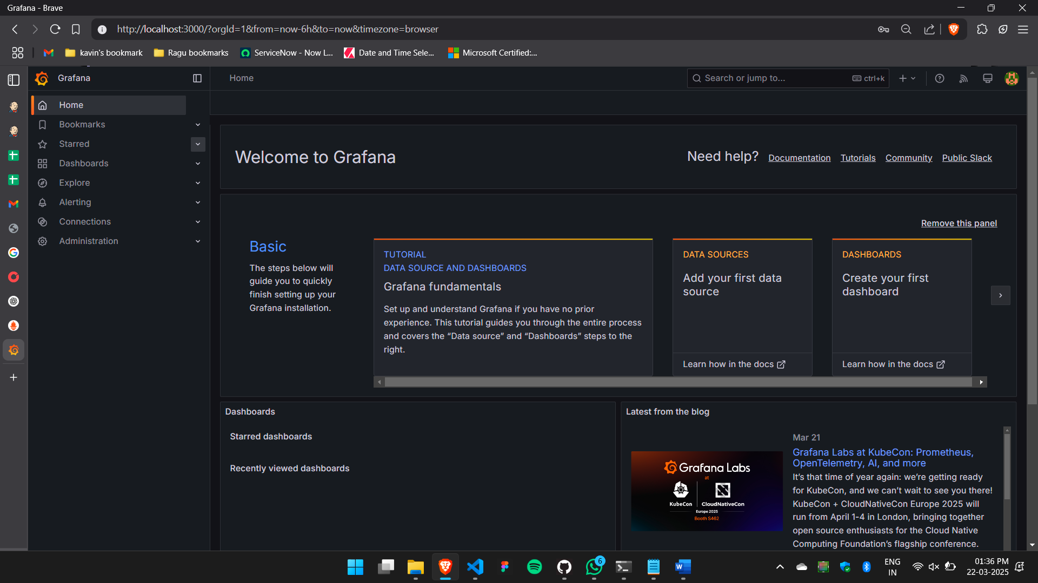

**Status in promethues:**

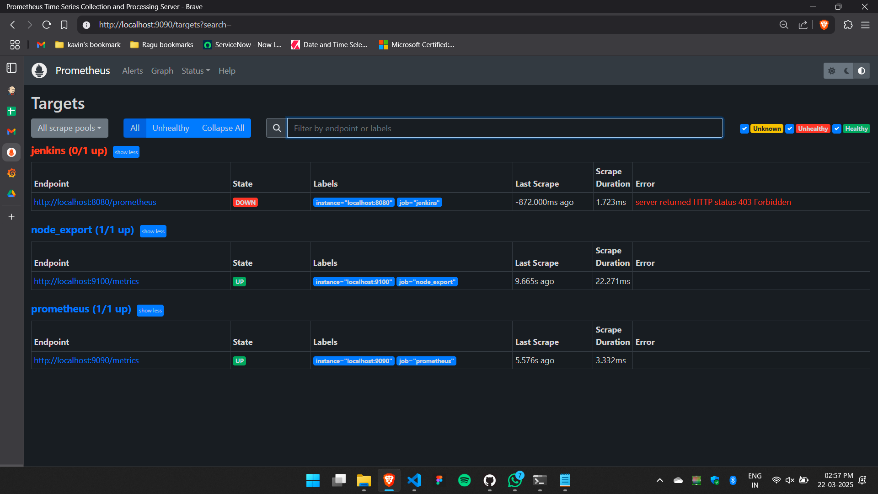

**Metrics in Prometheus:**

Node Exporter:

Dashboard:

Jenkins Overview:

Dashboard:

